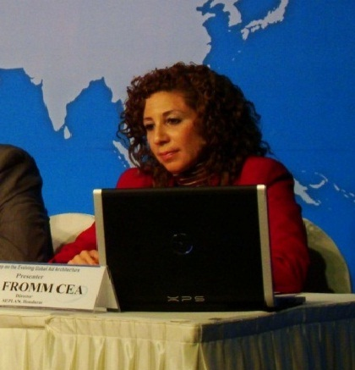
Lidia Fromm Cea, Viceminister for Social Policies, Honduras Ministry of Social Development

“The World Food Program (WFP) implements the School Feeding Program in over 70 countries worldwide. The partnership that has been institutionalized in Honduras is interesting, because, the Honduran government, through the Ministry of Social Development, funds 25 million dollars to the World Food Program on an annual basis in order for it to run operations for the School Feeding Program. The Honduran government provides 85% of the funding while the WFP provides 15% of the funding. Honduras is the 2nd largest donor to the World Food Program in Latin America, after Brazil. The WFP administers public government funds and purchases, stores, transports and distributes the food.
“Despite the fact that the Honduran government provides funding for their operations, the WFP has told the Government they need approval from HQ in Rome before they can give detailed information about their spending. We ask for this information to hold them to account – a funding gap has been identified and it cannot be necessarily figured out because we can’t get the detailed info.
“While the HQ may endorse IATI, it is easy to note that they don’t inform their offices nor do they explain the standard and its composition and relevance– so it is blank stares all around when we make reference to the IATI.
“It is interesting to observe how government complies with donor requirements regarding funding-financial reports, statements, financial and social audits, etc.-but when the government is the main donor and the “traditional” donor becomes the recipient, the requirements are not met with the same seriousness and promptness.
“These situations are marred by people when they won’t share the belief that information is a public good. Perhaps they don’t consider that a donor should provide detailed information to a government; perhaps it may come down to personality but IATI is the agreed standard for donor information and who is sitting at the table shouldn’t matter.”

