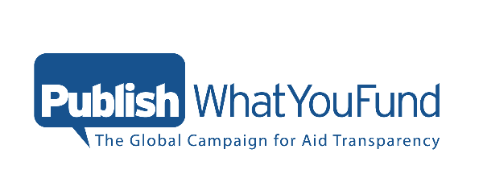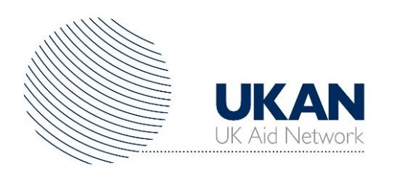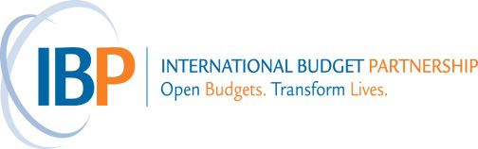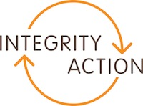

Opening Data – from Publication to Use for Sustainable Development
Roundtable discussion

Date: Monday 21 September 15:00-17.00
Place: Action Aid 33-39 Bowling Green Lane, London EC1R 0BJ

The importance of open and transparent data on aid flows into developing countries is now a generally accepted principle – it aims to enable better coordination of donors, more effective budget allocations within developing countries and support better accountability. All of this increases the overall effectiveness, results and long term impact of aid. The UK has historically been a strong leader in aid transparency at a political, policy and implementation level. The commitments made in the UK National Action Plan (NAP) for the Open Government Partnership (OGP) have played a clear role in helping to direct and strengthen that leadership.
A new two-year action plan is currently being drafted and provides a key moment to think about where next for aid transparency, to help shape new commitments and beyond. Publish What You Fund, the UK Aid Network, the International Budget Partnership and Integrity Action invite you to join us for a policy roundtable to discuss the future of aid transparency as part of the new NAP.
The roundtable will be an opportunity to discuss questions including:
- What is next for aid transparency: how do we move from data publication to data use?
- Who should be the main users of aid information and what is needed to foster greater interest from a broader range of ‘less technical’ civil society organisations?
- What kind of data use will make an impact on the effectiveness of aid?
- What concrete structures and policies could help enable this?

Following this roundtable, a note of the event and discussions will be produced which will also seek to inform some recommendations for the new NAP.

Concept Note
Opening Data – from Publication to Use for Sustainable Development

Objective
This roundtable discussion aims to steer discussion among a diversity of experts on development, open data and open government. The objective is to harvest key aspects of policy recommendations that can drive aid data use for better results and accountability.
Agenda and Framing Questions (draft)
15.00-15.05 – Setting out objectives, questions and next steps for the event by Chair
15.05-15.10 – Framing of current ‘make or break’ issues by Rupert Simons, Chief Executive Officer, Publish What You Fund
- Why are these conversations important?
- What’s the current landscape of aid transparency?
- Why are we doing this in the context of the Open Government Partnership new National Action Plan?
15.10-15.15 – Open Government Partnership – developing a new UK National Action Plan
- What is the process of developing a new National Action Plan?
- What has been the NAP contribution for the implementation of open government policies and practices?
- What are the challenges for a new NAP looking forward?

15:15-15:30 Open discussion/reactions/questions

15.30-15.40 – Civil society representative working with citizens and data users
- The experience of working with citizens/data users
- What are the challenges in the use of open aid information?
- What are the development objectives open data can help achieve?
15.40-15.50 – Representative of a transparency and open data initiative
- The experience of working with citizens/data users in other open government areas (budgets, contracting)
- How are citizens using this information?
- What are the data use challenges and lessons learned in working with citizens/civil society?
15.50-16.50 – Open discussion and feedback on the framing questions
- What other challenges and experiences have we seen?
- How can the UK government/DFID address them?
- How can a new aid transparency commitment support this agenda?
16.50-16.55 – Summary of key issues and outputs
16.55-17.00 – Closing remarks from Chair

